
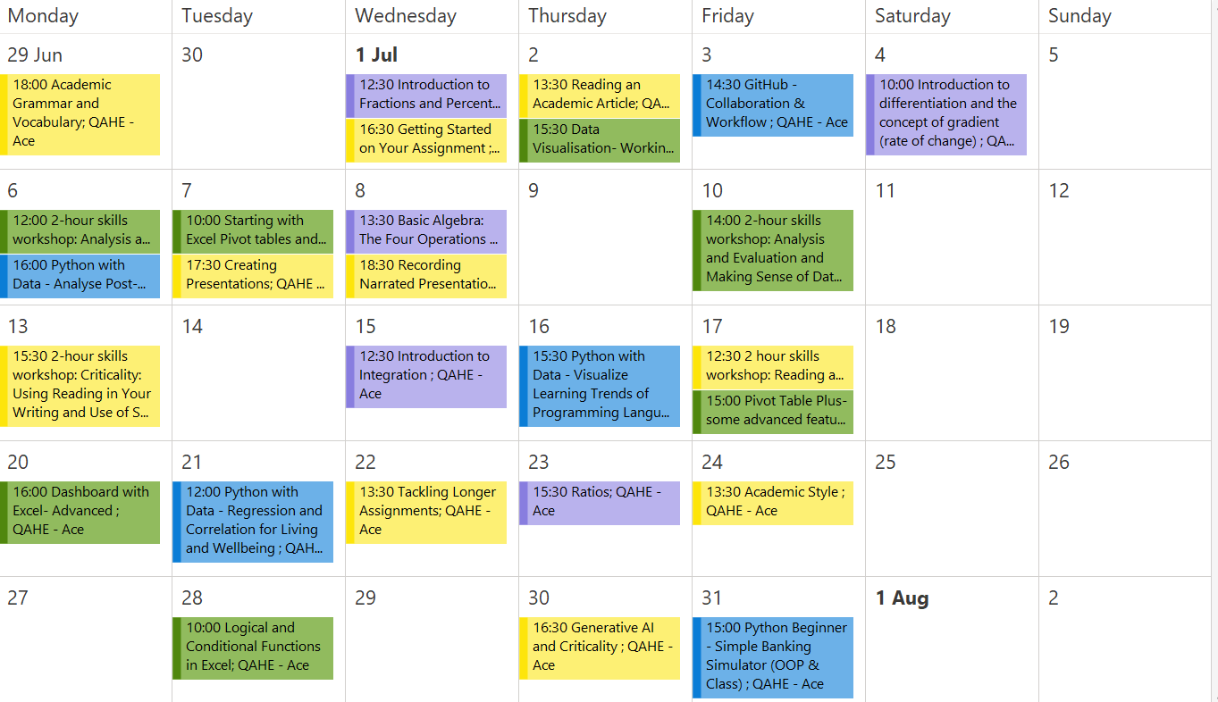

01-July Wednesday 12:30  Math Skills  Introduction to Fractions and Percentages and the Four Operations  This workshop will refresh your knowledge of fractions and percentages and will practise adding, subtracting, dividing and multiplying with fractions. | 01-July Wednesday 16:30  Study Skills  Getting Started on Your Assignment  The basics of writing styles and a look at how to approach your  assignment in its early stages. | 02-July Thursday 13:30  Study Skills  Reading an Academic Article  In this workshop, we look at one of the key academic sources: journal articles. How do we choose the right articles to read? How can we read articles  efficiently? You’ll learn how to use academic articles effectively in your research and writing. | 02-July Thursday 15:30  Excel/Data Skills  Data Visualisation- Working with Charts in Excel- Beginners  Learn how to determine the best type of chart to fit your data set and how to work with the chart elements.
03-July Friday 14:30  Computing Skills  GitHub - Collaboration & Workflow  In this workshop, we will explore how to use GitHub effectively for collaboration, including managing repositories, working with branches, and using pull requests to support team-based development workflows | 04-July Saturday 10:00  Math Skills  Introduction to differentiation and the concept of gradient (rate of change)  Learn basic differentiation rules and practice calculating derivatives step by step. Examples will show how differentiation applies to real-life situations such as speed, growth and optimisation | 06-July Monday 16:00  Computing Skills  Python with Data - Analyse Post-Uni Income  In this workshop, we’ll use a data analysis tool, pandas, to analyze historical data and find out post-university salaries of different majors on Google Colab | 06-July Monday 12:00  Study Skills  2-hour skills workshop: Analysis and Evaluation and Making Sense of Data  This 2 hour workshop first looks at the difference between evaluation and analysis and then puts this into practice by exploring how to make sense of data.

07-July Tuesday 10:00  Excel/Data Skills  Starting with Excel Pivot tables and charts- Intermediate  Learn to create pivot tables and charts to calculate, summarize, and analyse data so you can see comparisons, patterns, and trends in your data. Attend the Excel Starter workshop or book a one-to-one tutorial to learn the basics before you attend this workshop. | 07-July Tuesday 17:30  Study Skills  Creating Presentations  How to get started on your presentation and plan and organise it. | 08-July Wednesday 13:30  Math Skills  Basic Algebra: The Four Operations and the Indices  Learn how to do the + - / x with the letters and numbers and how to power them up or down | 08-July Wednesday 18:30  Study Skills  Recording Narrated Presentations - Live Demo  Live demo of recording narrated presentations.
10-July Friday 14:00  Excel/Data Skills  2-hour skills workshop: Analysis and Evaluation and Making Sense of Data  This 2 hour workshop first looks at the difference between evaluation and analysis and then puts this into practice by exploring how to make sense of data. | 13-July Monday 15:30  Study Skills  2-hour skills workshop: Criticality: Using Reading in Your Writing and Use of Sources  In this 2-hour skills workshop we'll look at developing criticality in your studies focusing on using reading in your academic writing and how to include sources effectively in assignments. | 15-July Wednesday 12:30  Math Skills  Introduction to Integration  Introduction to the mathematical process of integration. | 16-July Thursday 15:30  Computing Skills  Python with Data - Visualize Learning Trends of Programming Languages  In this workshop, we’ll use data analysis and visualization tools, pandas and matplotlib, to explore historical data of Stack Overflow posts and visualize the popularity of different programming languages on Google Colab.

17-July Friday 12:30  Study Skills  2 hour skills workshop: Reading and Notetaking  This 2 hour workshop looks at how to read an academic article as well as some strategies for effective notetaking. | 17-July Friday 15:00  Excel/Data Skills  Pivot Table Plus- some advanced features of Pivot Tables  Please attend "Starting With Pivot Table" workshop first if you are new to Pivots . | 20-July Monday 16:00  Excel/Data Skills  Dashboard with Excel- Advanced  We will be going one step further in working with Pivot Table by developing a dashboard in Excel. If you are new to Excel, please ensure you attend Starting With Pivot Table workshop first or make a one-to-one appointment before attending this workshop | 21-July Tuesday 12:00  Computing Skills  Python with Data - Regression and Correlation for Living and Wellbeing  In this workshop, we’ll perform linear/polynomial regression and explore survey data and apply numpy, pandas and matplotlib to visualize the correlation between different factors and to simulate the trend
22-July Wednesday 13:30  Study Skills  Tackling Longer Assignments  Explores challenges you might face when tackling longer pieces of writing. Topics include time management, structuring longer assignments, writing cohesive paragraphs, and developing density and complexity in your writing. | 23-July Thursday 15:30  Math Skills  Ratios  A ratio is a comparison of two quantities. Join the workshop to learn more! | 24-July Friday 13:30  Study Skills  Academic Style  A look at the conventions of academic writing and and tips on how to develop your academic style. | 28-July Tuesday 10:00  Excel/Data Skills  Logical and Conditional Functions in Excel  Learn how to use IF, AND OR Functions in Excel for data analysis.

ACE on Demand
Can't attend a workshop? Time doesn't suit?
Don't worry - you and your classmates can contact us and request a
workshop at a time and day that
work for you!
Scan the QR code to submit à

30-July Thursday 16:30  Study Skills  Generative AI and Criticality | 31-July Friday 15:00  Computing Skills  Python Beginner - Simple Banking Simulator (OOP & Class)  In this workshop, we’ll explain object-oriented programming (OOP) using class in Python and create a simple bank account simulator, instance, and class methods on Google Colab

